Solution for Module 2 Assignment using Web PivotTable
Assignment 1 provides experience with WebPivotTable, an open source application for business intelligence. Using WebPivotTable, you will customize a pivot table and extend it to show more aggregated fields. WebPivotTable is a pure Javascript application that can be used in any browser without plugins.
Before starting this assignment, you should read the Web pivot table tutorial. The tutorial demonstrates the usage of WebPivotTable and the OLAP cube source used in this assignment. It also demonstrates MDX to specify a pivot table. If you have not read the tutorial yet, please refer to it prior to starting this assignment.

Load the Data Cube
- Select the preloaded OLAP cube Microsoft Adventure Works (same cube used in tutorial) from the Demo list to create the pivot table.
- Take some time exploring the data cube before beginning on the details of the assignment.

Create the Pivot Table
Create a customized pivot table that shows the following:
    - Expand the “Promotion” dimension in the Fields List.
    - Select “Promotions” field in the Rows area.
    - Expand the “Delivery Date” dimension in the Fields List.
    - Select “Delivery Date.Month of Year” in the Columns area.
    - Expand the Measures in the Fields List.
    - Select “Average Sales Amount” in the values area
    - Take a screen snapshot and paste it into a document as the snapshot for part 2 of Assignment 1. The snapshot should show the All Product Categories with complete expansion of showing a subset of values for the rows and columns.
    - Keep the sheet open for the next part.
    - Separately, answer quiz questions 1 to 5.

Extend the Pivot Table
  - Add “Source Currency” level (Do NOT include “ALL” level) from the Source Currency dimension to the Filters area. You may need to move it from the Rows area to the Filters area.
  - Create a filter such that the pivot table displays value only for “Canadian Dollar” and “US Dollar”.
  - Take a screen snapshot and paste it into a document as the snapshot for part 3 of Assignment 1. The snapshot should show the All Periods and January Average Sales Amount for All Promotions along with a subset of the expansion for Reseller promotions specified in part 3.
  - Keep the sheet open for the next part.
  - Separately, answer quiz questions 6 and 7.

Extend the Pivot Table with Filter Changes and Rollups
- Modify the filter to show results only for the source Currency “EURO”. I suggest that you clear the filters first before setting the new filter. Otherwise, the old filters still remain.
- Collapse all reseller promotions except for Excess Inventory. Show only the subcategories within the Excess Inventory item.
- Remove the pivot chart so that the sheet only displays the pivot table.
- Take a screen snapshot and paste it into a document as the snapshot for part 4 of Assignment 1. The snapshot should show the Average Sales Amount for All Promotions along with a subset of the expansion for Reseller promotions.
- Separately, answer quiz questions 8 to 13.

Submission and Grading
You also need to submit the screen snapshots from parts 2 and 4 in a document. I prefer a Word document to facilitate comments in grading. Each snapshot has one-third weight. You should ensure that your snapshots show requested areas of the pivot table.
Solution: first snapshot (Areas, pivot chart, Rows with expansion of product categories)
2018 version of WebPivotTable
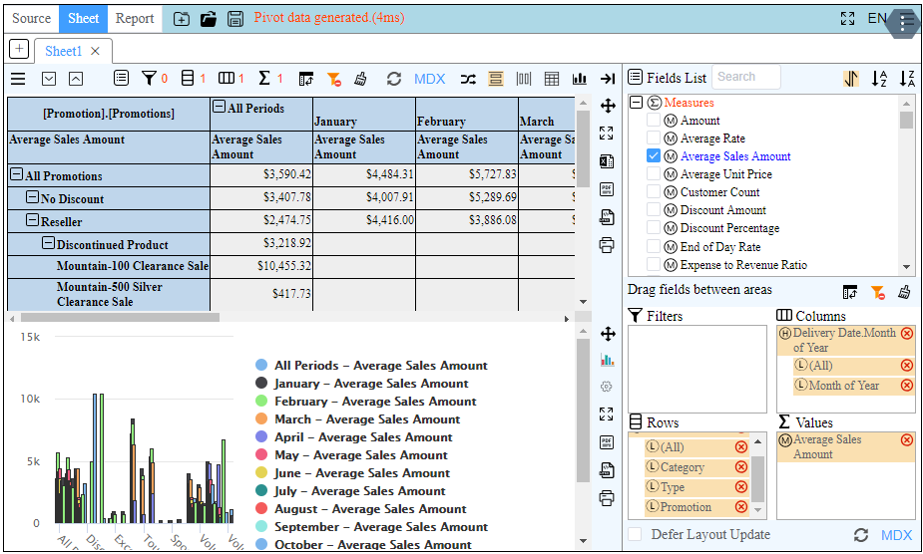
2020 version of WebPivotTable
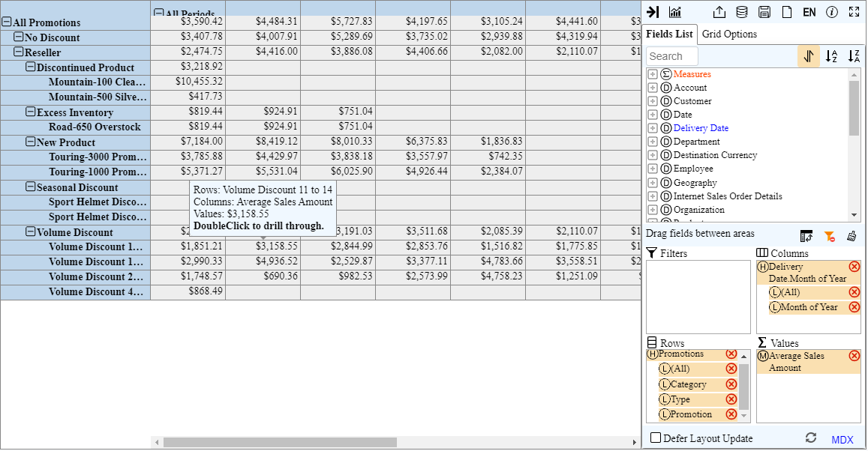

Solution: second snapshot (Source Currency filter field with USA and Canadian dollars)
2018 version of WebPivotTable
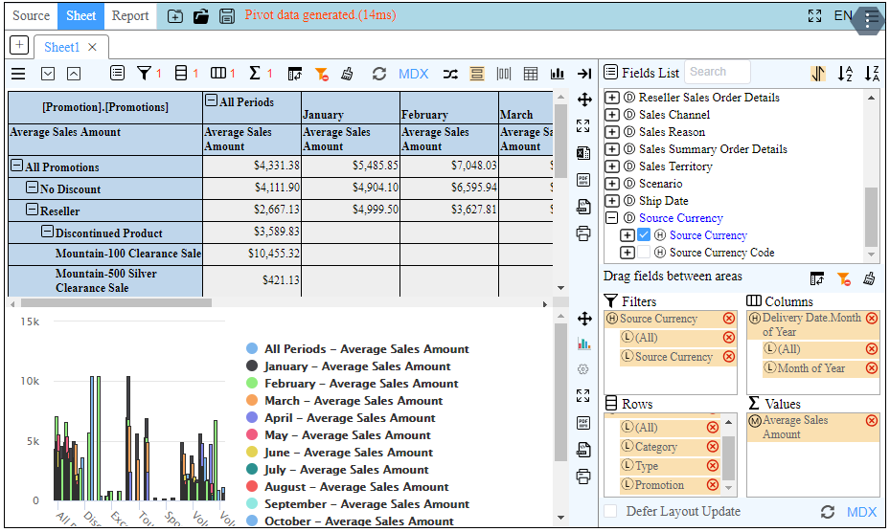
2020 version of WebPivotTable
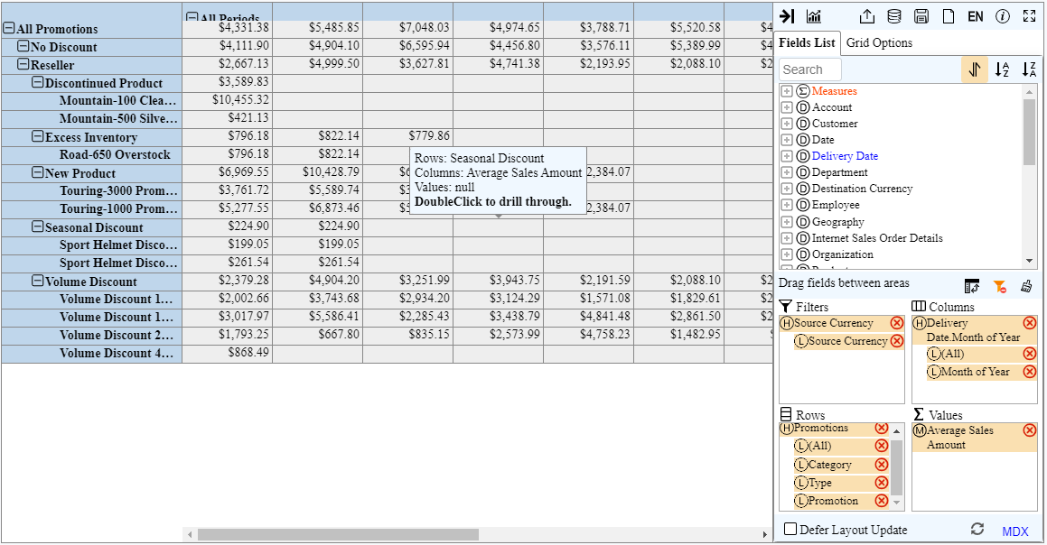

Solution: third snapshot (no pivot table, collapse of Reseller promotions, EURO currency source)
2018 version of WebPivotTable
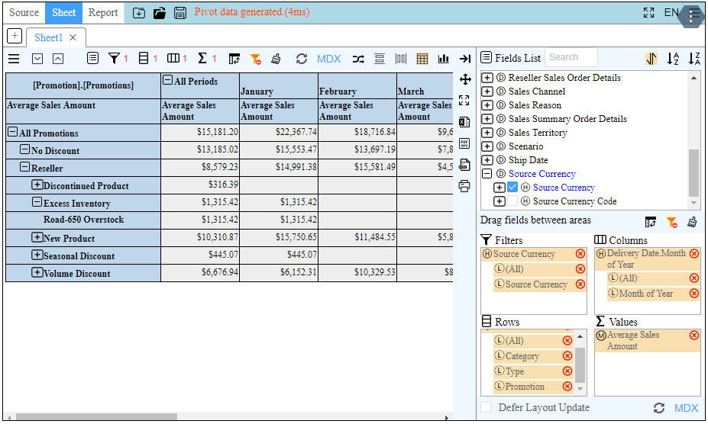
2020 version of WebPivotTable
